Instructions for completing a Fillable
PDF form
Please review the following instructions for successfully completing the Ambassador Application and Agreement fillable PDF form:
x Use only the latest version of Adobe Reader to complete fillable PDF forms. Macintosh and Windows versions of the free Adobe Reader are available from Adobe at http://get.adobe.com/reader/.
x Before completing the application, save the application form (PDF format) to a location on your computer. (Example: Desktop or Documents).
- Instructions: Right click on the form and click “Save as”.
- Save to your Desktop or Documents.
x Once you have saved the form to your computer, you are ready to complete the form.
x Open the Ambassador Application and Agreement form. x After you have completed the form, save a final version of the file to your computer.
x When ready, don’t forget to attach the Ambassador Application and Agreement form via email to the Ambassador Coordinator.
x Do not complete the form online within your web browser, your data will NOT be saved. Please save it to your computer first, then fill it out!

AMBASSADOR APPLICATION AND AGREEMENT
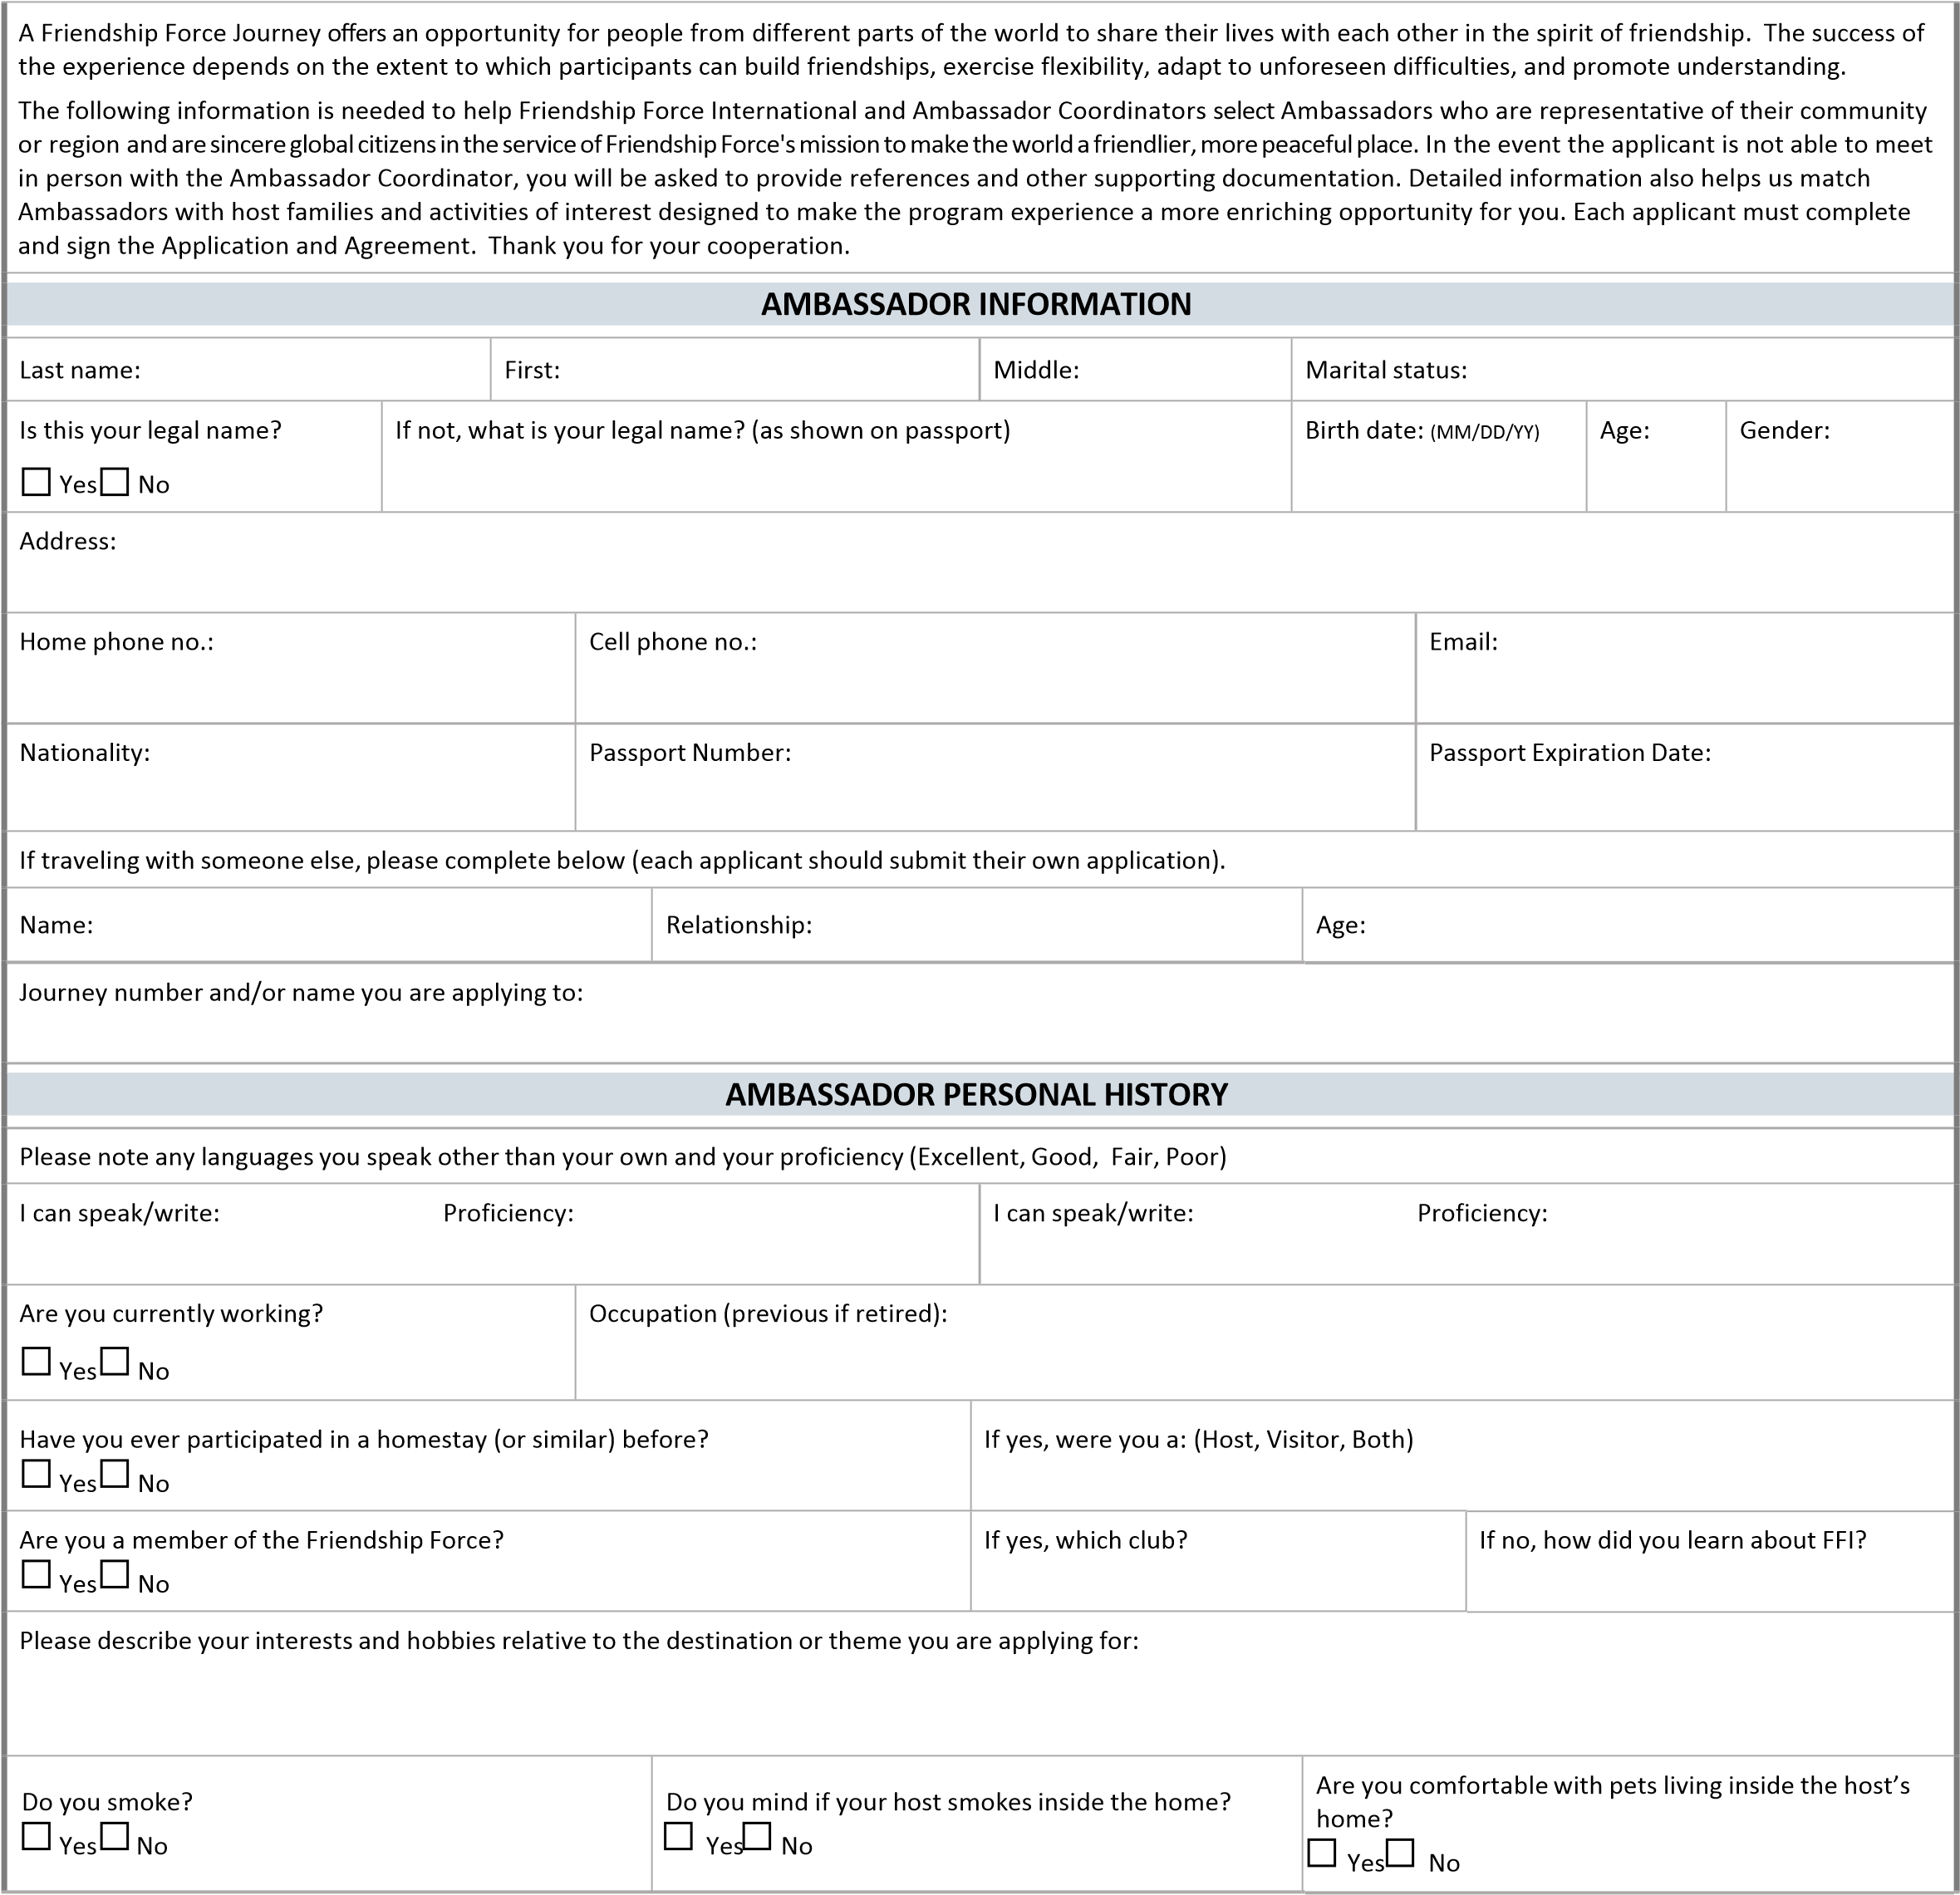

HEALTH AND MOBILITY
Participation in a Friendship Force homestay may require a greater level of physical activity than an Ambassador is accustomed to, such as carrying luggage, climbing stairs, riding public transportation, and walking longer distances, among others. For more specific health and mobility requirements for this program, please ask the Ambassador Coordinator for the Health and Mobility Checklist from the host club. Ambassadors may be required to provide supporting medical documentation to be accepted.
Are you able to carry your own luggage upstairs, and/or over long periods of time by yourself?  Yes No | If no, please elaborate:
Are you able to climb a flight of stairs several times a day if needed, without assistance?  Yes No | If no, please elaborate:
Are you able to ride and navigate on public transportation easily, perhaps several times in a day?  Yes No | If no, please elaborate:
In the past three years, have you had any major health issue that would preclude you from carrying out active elements of a  Friendship Force Journey?  Yes No | If yes, please elaborate:
How would you describe your own day-to-day activity level at home, on your own? | Please select one:  Not very active Active Sometimes Active every day Very active
Do you have any particular diet, health, medical or allergy issues that require special consideration?  Yes No | If yes, please specify (examples: vegetarian, allergy to penicillin or animals, high blood pressure). Ambassadors may be required to provide supporting medical documentation from their doctor to be accepted on this program.
Please provide a reference that your Ambassador Coordinator or Friendship Force International may contact to verify your ability to participate fully in this program. (preferably the last Ambassador or Host Coordinator that you traveled with):
Name: |  | Phone number: |  | Email: |  | Relationship to you:
Name: |  | Phone number: |  | Email: |  | Relationship to you:
EMERGENCY CONTACT INFORMATION
Person to contact in case of emergency: |  |  | Relationship: |  | Home phone: |  | Work phone: | Email:
Name:
Name:
STATEMENT OF PURPOSE
Friendship Force International considers each ambassador and each host to be a “Citizen Diplomat,” whom we entrust as a person who is committed to improving international relationships through people‐to‐people diplomacy during and after the program. To help us and your Ambassador Coordinator evaluate your application, please write a brief personal goal that you wish to accomplish from this experience. Please also describe how you will keep the personal and institutional relationships alive after you return home.
FRIENDSHIP FORCE INTERNATIONAL
AMBASSADOR APPLICATION AND AGREEMENT
Friendship Force International was founded in 1977 with a single mission: to promote global understanding across the barriers that separate people. A nonprofit organization, Friendship Force International is active in more than 60 countries, promoting friendship and goodwill through an extensive program of more than 300 homestays each year. In consideration of his/her selection, the person signing this Agreement ("Ambassador") agrees to the following:
- The Ambassador Fee entitles the Ambassador to participate in a specific Journey and covers only the items specified in the itinerary. The schedule of payment of Ambassador Fees must be observed.
- The Ambassador recognizes that connected with any travel there are risks of loss, damage, and injury to persons and property, and the Ambassador is willing to assume and bear those risks. The Ambassador also recognizes that he/she is responsible for complying with all laws of all countries visited. Therefore, the Ambassador, in consideration of his/her selection by Friendship Force International, agrees to and does hereby release, indemnify, and hold harmless Friendship Force International (which shall include the directors, officers, and employees thereof, as well as its volunteer workers) from all claims, actions, and causes of action based upon or by reason of any loss, damage, or injury to the Ambassador's person or property, arising out of or in any manner connected with any aspect of the program or by reason of the Ambassador's failure to comply with any law in any country in which he/she may travel in connection with the program. Friendship Force International shall have no liability or obligation to return the Ambassador to his/her home community if the Ambassador should miss the return trip due to illness, injury, failure to report to the airport at the prescribed time, or for any other reason.
- All Friendship Force Ambassadors are required to secure adequate travel and medical insurance to cover emergencies during their Journey. No travel, health, or accident insurance is provided by Friendship Force International, although one may be recommended. This requirement can be fulfilled through the Ambassador’s existing insurance policy if it covers international travel, including emergency repatriation, or through a separate travel insurance policy. All travel will be subject to regulations and limitations contained in the ticket(s) issued to the Ambassador.
- Any request for cancellation of this agreement must be made in writing to the local Ambassador and Host Coordinator and to the Friendship Force International Regional Support Manager overseeing the specific Journey. If an Ambassador cancels more than 60 days before departure, FFI will refund all FFI Ambassador Fees and Host Club Program Fees already paid. If an Ambassador cancels 60 days or less prior to the departure, FFI has no obligation to refund the ambassador fee paid. If FFI cancels a Journey, all FFI Ambassador Fees and Host Club Program Fees paid will be returned to Ambassadors. If this Ambassador Agreement is not for a club‐to‐club Journey, but instead for a themed or Global Journey please consult your FFI Regional Support Manager for cancellation and refund policies.
- Friendship Force International may cancel this agreement if it is unsuccessful in establishing a Journey which satisfies the goals of Friendship Force International for any reason, including cancellation of or unacceptable changes to the airline arrangements or failure of the local committee to recruit the required number of Ambassadors. In such cases, the Ambassador Fee will be refunded except the $25 portion designated as non‐refundable.
- If Friendship Force International is making travel arrangements for your Journey, any price increase for transportation will be passed on to the Ambassador until the time that the full Ambassador Fee is received at the headquarters office of Friendship Force International in Atlanta, Georgia, USA. After that time, no increase will be passed on to the Ambassador, except in the case of carrier or routing changes beyond the control of Friendship Force International.
- The Friendship Force Ambassador hereby agrees to follow the provisions stated above and: a) to accept travel arrangements as arranged by Friendship Force International, where applicable b) to participate fully in the homestay arrangements as arranged (unless previously discussed and adjusted), c) to pay the Ambassador Fee when due, d) to accept the decision making authority of the Ambassador and Host Coordinator during the program, e) to accept that the Journey is a public event and that the photograph and name of the Ambassador may be used by the local and national media, Friendship Force clubs and Friendship Force International in their publications, online and social media; and f) to comply with all commitments made to Friendship Force International as covered by this form, and the "Policies and Procedures" Ambassador standards established by Friendship Force International found here.
- Upon acceptance of the Ambassador into the program, this Agreement shall become effective and binding upon Friendship Force International and the Ambassador, and shall be governed by the laws of the state of Georgia, USA. No representations, or statements, whether oral or written, other than those contained herein, shall be binding on Friendship Force International. In the event the Ambassador fails to abide by any of the terms and conditions of this agreement, Friendship Force International may terminate this Agreement without any penalty or liability to Friendship Force International.
Ambassador Pledge:
My main objective as I join this Journey is for cultural understanding, global friendship building and to make the world a more peaceful place. My health is good enough to keep up with the group activities as planned in the initial itinerary and I state that my answers in the Health and Mobility section of this form are true and accurate.
As an Ambassador, I am aware that my actions reflect on myself as a citizen diplomat, and as a representative of Friendship Force and its mission, the country and community I come from and the club I am a member of. I promise to conduct myself in an exemplary manner. I understand the Ambassador Coordinator of this Journey has been given authority by Friendship Force International headquarters to lead and conduct this program for the best interests of all parties concerned. The Ambassador and
Host Coordinator has the authority to remove any person from a Journey who is not in compliance with the goals of Friendship Force International. In case there is a need to use hotels or other accommodations as auxiliary housing, or a need or desire on my part for a single room on the add‐on part of the program, I will bear the expense.
I have read the Ambassador Agreement provided with this Application and accept its terms.
I hereby agree to secure adequate travel and medical insurance for the duration of the Journey.
Yes No
If no, I hereby waive the requirement of Friendship Force International which states that all participants carry travel insurance; and I agree to release Friendship Force International, its agents, the Ambassador Coordinator, my host and any vendors who participate in this program from liability, loss or damages: I agree
I certify that I am 18 years of age or older and have completed this application to the best of my knowledge and believe it is true.
Signature of Ambassador Date Signature of Parent or Guardian Date
If Ambassador is under 18 years old, both signatures are required.
Ambassadors under 18 must travel with a parent or guardian. Ambassadors under 16 must be hosted together with a parent or guardian.
Name of guardian for youth under 18:
*If I am below 18, I am including a letter of responsibility by my guardian, parent or adult supervisor allowing me to take part in all activities of this program.
© Revised February 2018 Friendship Force International, Inc.

